**Mandatory Exercise 4 – Advanced JavaScript with React – CONNECT 4**

1. **Project install**

TRUPTI@LAPTOP-RLRGMMNC MINGW64 /e/frontwebutvecklare/projects

npx -i install create-react-app mandatory-advanced-js4

cd mandatory-advanced-js4/

git init

git commit -m "Initial setup"

git remote add origin git@github.com:truptigaonkar/mandatory-advanced-js4.git

git push -u origin master

1. **React with material (**<https://material-ui.com/demos/buttons/>)

PS E:\frontwebutvecklare\projects\mandatory-advanced-js3> npm install --save @material-ui/core

1. **React with Reactstrap**

<https://reactstrap.github.io/>

Adding Bootstrap

1. Install reactstrap and Bootstrap from NPM. Reactstrap does not include Bootstrap CSS so this needs to be installed as well:

npm install bootstrap --save

npm install --save reactstrap react react-dom

1. Import Bootstrap CSS in the src/index.js file:

import 'bootstrap/dist/css/bootstrap.min.css';

1. Import required reactstrap components within src/App.js file or your custom component files:

import { Button } from 'reactstrap';

1. Now you are ready to use the imported reactstrap components within your component hierarchy defined in the render method. Here is an example [App.js](https://gist.github.com/Thomas-Smyth/006fd507a7295f17a8473451938f9935) redone using reactstrap.
2. Import the components you need

Danger!

import React from 'react';

import { Button } from 'reactstrap';

export default (props) => {

return (

<Button color="danger">Danger!</Button>

);

};

1. Get all the components

Reactstrap components:

<https://reactstrap.github.io/components/navbar/>

React + Bootstrap component

<https://react-bootstrap.github.io/components/alerts/>

1. **React with Font Awesome**

<https://stackoverflow.com/questions/23116591/how-to-include-a-font-awesome-icon-in-reacts-render>

f you are **new to React JS** and using **create-react-app cli** command to create the application, then run the following NPM command to include the latest version of font-awesome.

npm install --save font-awesome

import font-awesome to your index.js file. Just add below line to your index.js file

import '../node_modules/font-awesome/css/font-awesome.min.css';

or

import 'font-awesome/css/font-awesome.min.css';

Don't forget to use **className** as attribute

render: function() {

return <div><i className="fa fa-spinner fa-spin">no spinner but why</i></div>;

}

1. **React with Google fonts**

<https://fonts.google.com/>

* 1. Add link in index.html

<link href="https://fonts.googleapis.com/css?family=ZCOOL+KuaiLe" rel="stylesheet">

* 1. Add following to get proper fonts in css file:

App.css

*{

font-family: 'ZCOOL KuaiLe', cursive;

*/* font: 700 20px/1.5 'Indie Flower', cursive; */*

}

1. **Deploying on github server:**

<https://reactgo.com/deploy-react-app-github-pages/>

### **1. Add homepage**

**package.json**

{

"homepage": "https://truptigaonkar.github.io/mandatory-advanced-js4",

"name": "mandatory-advanced-js4",

"version": "0.1.0",

"private": true,

"dependencies": {

"@material-ui/core": "^3.9.3",

"bootstrap": "^4.3.1",

"font-awesome": "^4.7.0",

"gh-pages": "^2.0.1",

"react": "^16.8.6",

"react-dom": "^16.8.6",

"react-scripts": "2.1.8",

"reactstrap": "^8.0.0"

},

"scripts": {

"predeploy": "npm run build",

"deploy": "gh-pages -d build",

"start": "react-scripts start",

"build": "react-scripts build",

"test": "react-scripts test",

"eject": "react-scripts eject"

},

"eslintConfig": {

"extends": "react-app"

},

"browserslist": [

">0.2%",

"not dead",

"not ie <= 11",

"not op_mini all"

]

}

### **2. Install gh-pages**

PS E:\frontwebutvecklare\projects\mandatory-advanced-js4> npm install --save gh-pages

### **3. Deploy script**

**package.json**

{

"homepage": "https://truptigaonkar.github.io/mandatory-advanced-js4",

"name": "mandatory-advanced-js4",

"version": "0.1.0",

"private": true,

"dependencies": {

"@material-ui/core": "^3.9.3",

"bootstrap": "^4.3.1",

"font-awesome": "^4.7.0",

"gh-pages": "^2.0.1",

"react": "^16.8.6",

"react-dom": "^16.8.6",

"react-scripts": "2.1.8",

"reactstrap": "^8.0.0"

},

"scripts": {

"predeploy": "npm run build",

"deploy": "gh-pages -d build",

"start": "react-scripts start",

"build": "react-scripts build",

"test": "react-scripts test",

"eject": "react-scripts eject"

},

"eslintConfig": {

"extends": "react-app"

},

"browserslist": [

">0.2%",

"not dead",

"not ie <= 11",

"not op_mini all"

]

}

### **4. Setup source to gh-pages branch.**

Go to your repository -> Settings

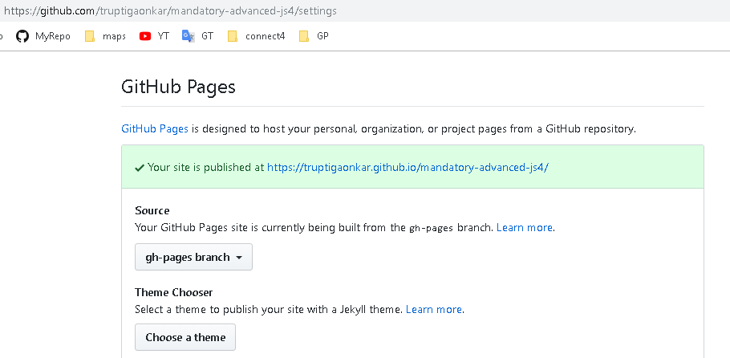

Click on given url to see your webpage